Erma M. (Okley) Arend
August 18, 1910 – June 21, 1964

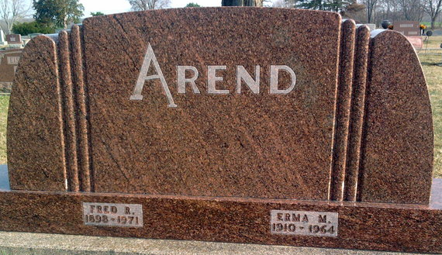
Photo by Thomas Liby

ELWOOD NEWS

Mrs. Erma Arend, wife of Fred Arend, former Elwood resident and now of Bluffton, died Sunday morning in Bluffton following an illness of several months.
Survivors are the husband and four children: Linda of Fort Wayne, Mrs. Joe Roberts of Noblesville, and Jim and Kenneth, at home; her mother, Mrs. Golke, and a brother, Henry Golke of Ohio.
Funeral services were conducted in Bluffton with burial at that place.

Anderson Daily Bulletin; Anderson, Indiana
Thursday, June 25, 1964
*****
Indiana, Death Certificates, 1899-2011
Name: Erma Arend
[Esma Okley]
Gender: Female
Race: White
Age: 53
Marital status: Married
Birth Date: 18 Aug 1910
Birth Place: Ohio
Death Date: 21 Jun 1964
Death Place: Bluffton, Wells, Indiana , USA
Father: R F Okey [sic]
Mother: Minnie Knarr
Informant: Admission sheet
Burial: June 23, 1964; Elm Grove Cemetery; Bluffton, Indiana

