Dean E. Archbold
December 20, 1941 – January 3, 2012

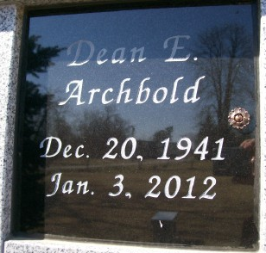
Photo by Scott Shoup

Dean E. Archbold, 70, of Bluffton, passed away on Tuesday, Jan. 3, 2012, at Lutheran Hospital, Fort Wayne. Born Dec. 20, 1941, in Adams County, he was the son of Harold E. and Wilma (Carnes) Archbold.
He is survived by his wife of nearly 50 years, Patricia K. (Bauermeister) Archbold of Bluffton; daughter, Kimberly Fiechter of Bluffton; and sons, Bret E. Archbold of Ocean Springs, Miss., and Darin D. (Amy) Archbold of Fort Wayne.
Dean was lovingly referred to as "Grandpa Dean" to seven grandchildren. Also surviving is his brother, Lyle (Janelle) Archbold of Ridgetown, Ontario, Canada; and sister, Marilyn Lindquist of Farmington, Conn.
Funeral service is 1 p.m. Friday at the Chapel, Fort Wayne, with calling from 11 a.m. to 1 p.m. Pastor Rick Hawks officiating. Calling also from noon to 8 p.m. Thursday at Thoma/Rich, Chaney & Lemler Funeral Home, Bluffton.
Memorials may be made to Mad Anthony's Children's Hope House on Lutheran Hospital Campus or the Jeff Gordon's Children's Foundation.

Journal Gazette, Allen County, Indiana
January 5, 2012.

