Wayne W. Andrews
November 4, 1936 – December 16, 1992

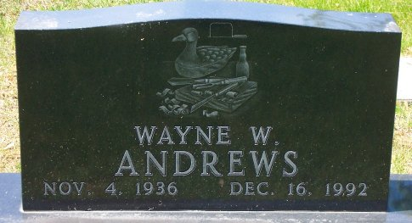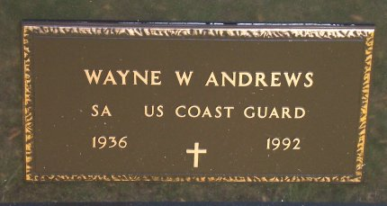
Photo by Bob & Nancy Cannon

Wayne W Andrews
in the Indiana, Death Certificates, 1899-2011
Name: Wayne W Andrews
Gender: Male
Race: White
Age: 56
Marital status: Divorced
Birth Date: 4 Nov 1936
Birth Place: Cleveland, OH
Death Date: 16 Dec 1992
Death Place: Warsaw, Kosciusko, Indiana, USA
Father: William Andrews
Mother: Isabella Mako
Informant: Kim Wall; daughter; Bluffton, Indiana
Burial: December 21, 1992; Elm Grove Cemetery; Bluffton, Indiana

