Vivian L. M. (Runyon) Andrews
December 8, 1932 - August 3, 2020

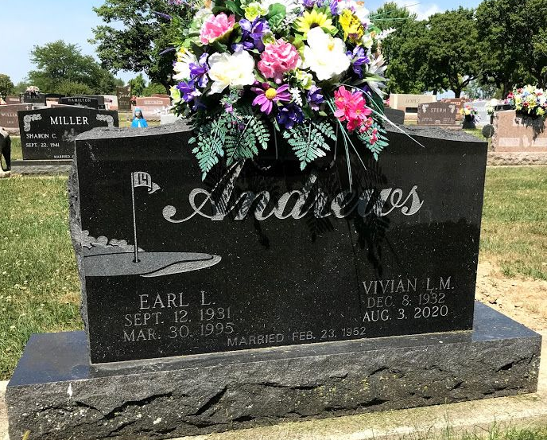
Photo by SMMR

Vivian L. M. Andrews, 87 of Bluffton, IN passed away at her home Monday evening, August 3, 2020. Vivian was born December 8, 1932 in Southey Saskatchewan, Canada to Alton T. and Stella (Solie) Runyon. She lived in Canada until 1941, when she moved to Wells County. She graduated from Lancaster High School in 1951.
Vivian worked at Caylor-Nickel for 28 years as a Supervisor over the Registration Department. She was a member of the First United Methodist Church since 1944.
Vivian and Earl Andrews were married on February 23, 1952 in Wells County. They celebrated 43 years together until Earl preceded her in death on March 30, 1995.
Vivian is survived by her son, Tim (Vicki) Andrews of Warren, and daughters Gail Benedict of Bluffton and Lisa (Mark) Leas of Montpelier, along with 8 grandchildren and 20 great-grandchildren.
Vivian is preceded in death by her parents, her husband, a brother Floyd Runyon, and a sister Marlyn Milholland.
Private family services will be held on Saturday (August 8, 2020) at the Thoma/Rich, Lemler Funeral Home with Pastor Lyle Breeding officiating. Burial will take place at Elm Grove Cemetery. Memorials may be made to Sonlight Wesleyan Church of Bluffton. ​
Thoma/Rich, Lemler Funeral Home, Wells County, Indiana
August 4, 2020

