Willis Dale Anderson
November 7, 1906 – September 14, 1972

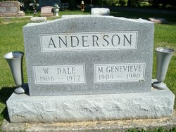
Photo by Smalltown

Dale Anderson Rites Saturday
Ill three months, W. Dale Anderson, 66, of 923 West Washington St., died at 7:05 a.m. today at Clinic Hospital. A son of James M. and Laura Wirick Anderson, he was born Nov. 7, 1905 in Paulding County, O. His marriage to Mary Genevieve Ware, who survives, took place Sept. 29, 1929, in Richmond.
A retired employee of Franklin Electric Co., he was a member of the Nazarene Church.
Surviving, in addition to the wife, are three sons, James W., Philip D. and Noel D., all of Bluffton; two daughters, Mrs. Howard (Karen) Penrod of Fairmount and Mrs. Ralph (Kay) Beals of Bluffton; a brother, Victor Anderson of Bluffton; a sister, Miss Martha Anderson of Bluffton, 17 grandchildren and three step-grandchildren.
Friends may call after 7 p.m. today at the Goodwin Funeral Home and until 12:30 p.m. Saturday, at which time the body will be taken to the Nazarene Church for services at 1:30 p.m. Rev. Walter Graeflin will officiate at the services and burial will be in the Elm Grove Cemetery.

News Banner, Wells County, Indiana
Thursday, December 14, 1972

