Raymond F. Anderson
November 5, 1893 – September 21, 1944

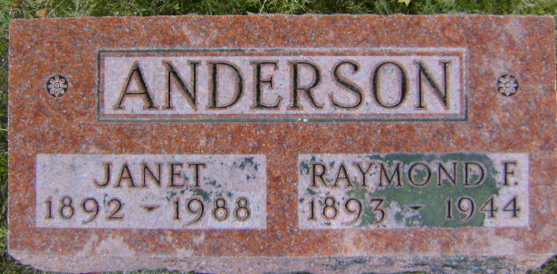
Photo by Bruce Sonner

Raymond Anderson
in the Indiana, Death Certificates, 1899-2011
Name: Raymond Anderson
Gender: Male
Race: White
Age: 50
Marital status: Married
Birth Date: 5 Nov 1893
Birth Place: Adams Co Ind
Death Date: 21 Sep 1944
Death Place: Bluffton, Wells, Indiana, USA
Father: John B Anderson
Mother: Maria Elizabeth Pusey
Spouse: Janet Neff; aged 52 years
Informant: Mrs. Raymond Anderson; Bluffton, Indiana
Burial: September 24, 1944; Elm Grove Cemetery; Bluffton, Indiana

