Nellie Janet (Neff) Anderson
May 1, 1892 – September 3, 1988

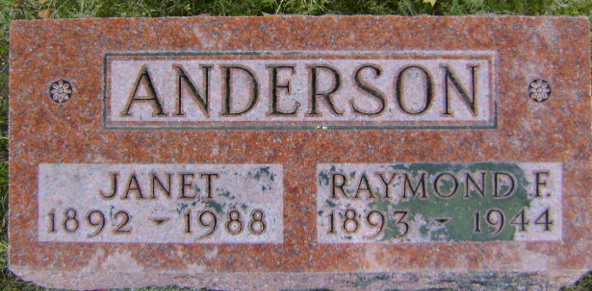
Photo by Bruce Sonner

Nellie Janet Anderson
in the Indiana, Death Certificates, 1899-2011
Name: Nellie Janet Anderson
[Nellie Janet Neff]
Gender: Female
Race: White
Age: 96
Marital status: Widowed
Birth Date: 1 May 1892
Birth Place: Michigan Town, In
Death Date: 3 Sep 1988
Death Place: Bluffton, Wells, Indiana, USA
Father: Amos H Neff
Mother: Zippie Hupp
Informant: Jerry Crandall; nephew; Bluffton, Indiana
Burial: September 6, 1988; Elm Grove Cemetery; Bluffton, Indiana

