Martha Leona Anderson
January 3, 1895 – February 8, 1984

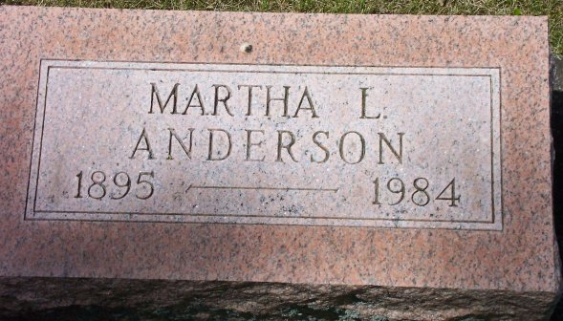
Photo by Bob & Nancy Cannon

Martha Leona Anderson
in the Indiana, Death Certificates, 1899-2011
Name: Martha Leona Anderson
Gender: Female
Race: White
Age: 89
Marital status: Never Married (Single)
Birth Date: 3 Jan 1895
Birth Place: Ohio
Death Date: 8 Feb 1984
Death Place: Bluffton, Wells, Indiana, USA
Father: James M. Anderson
Mother: Laura E. Wirick
Informant: Eileen Elzey; niece; Bluffton, Indiana
Burial: February 10, 1984; Elm Grove Cemetery; Bluffton, Indiana

