Bernice A. (Newman) Anderson-Ewing
April 14, 1907 – February 12, 1997

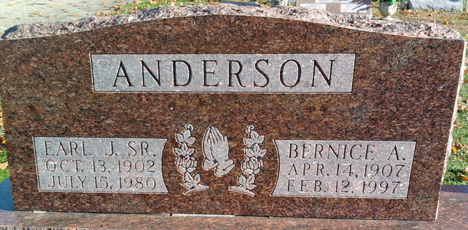
Photo by Thomas Liby

Bernice A Ewing
in the U.S., Social Security Applications and Claims Index, 1936-2007
Name: Bernice A Ewing
[Bernice A Anderson ]
[Bernice A Newman]
Gender: Female
Birth Date: 14 Apr 1907
Birth Place: Marion, Indiana
Death Date: 12 Feb 1997
Claim Date: 17 Feb 1970
Father: Gilford L Newman
Mother: Julia Duff
SSN: xxx
Citizenship or Alien Status: U.S. citizen.
Type of Claim: Duplicate request; evidence of identity only submitted.
Notes: 12 May 1982: Name listed as BERNICE A EWING; 11 Feb 1970: Name listed as BERNICE A ANDERSON
*****

U.S., Social Security Death Index, 1935-2014
Name: Bernice A. Ewing
Social Security Number: xxx
Birth Date: 14 Apr 1907
Issue Year: Before 1951
Issue State: Indiana
Last Residence: 85375, Sun City West, Maricopa, Arizona, USA
Last Benefit: 85351, Sun City, Maricopa, Arizona, USA
Death Date: 12 Feb 1997

