Mary D. (Kulscar) Alfather
October 17, 1912 – April 13, 1989

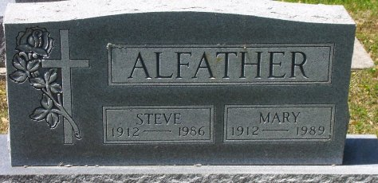
Photo by Bob & Nancy Cannon

Mary D Alfather
in the Indiana, Death Certificates, 1899-2011
Name: Mary D Alfather
[Mary D Kulski]
Gender: Female
Race: White
Age: 76
Marital status: Widowed
Birth Date: 17 Oct 1912
Birth Place: Bluffton, In
Death Date: 13 Apr 1989
Death Place: Bluffton, Wells, Indiana, USA
Father: Kalman Kulscar
Informant: Kim Wall; granddaughter
Burial: April 15, 1989; Elm Grove Cemetery; Bluffton, Indiana

