Charles White
April 7, 1821 – November 14, 1905

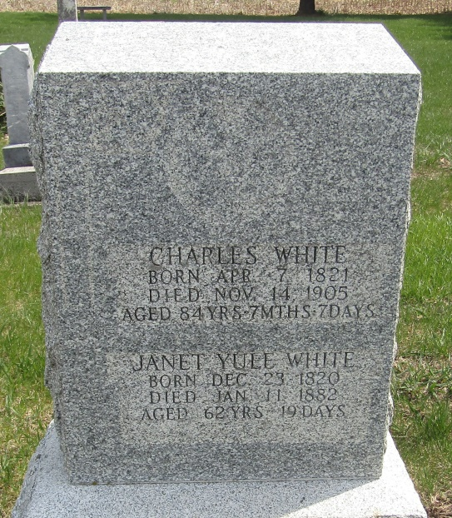

Charles Mut
in the Indiana, U.S., Death Certificates, 1899-2011
Name: Charles White
Gender: Male
Race: White
Age: 84
Marital status: Married
Birth Date: 7 Apr 1821
Birth Place: Schttord
Death Date: 14 Nov 1905
Death Place: Ossian, Wells, Indiana, USA
Father: Charles White
Mother: Isabell Campbell
Spouse: ?oren
Informant: Charles White; Ossian, Indiana
Burial: November 16, 1905; Elhanan Cemetery

