Jacob Summers
February 16, 1816 – January 18, 1866

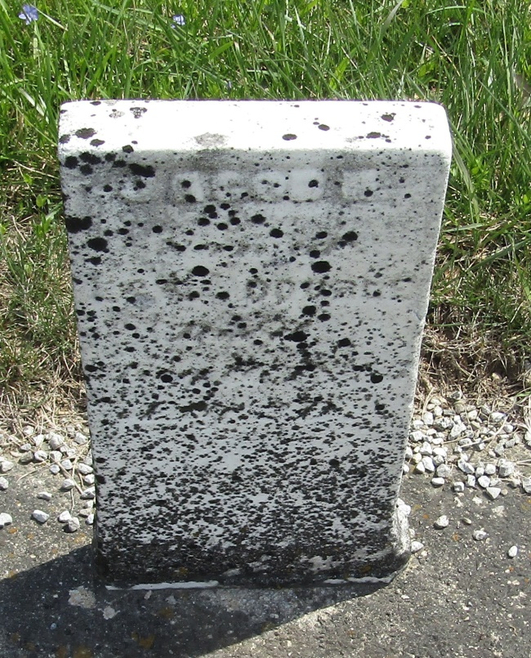

When Jacob Summers was born in 1816 in Page County, Virginia, his father, Joshua was 34 and his mother, Lytha was 30.
He moved to Allen County, Indiana in 1840 and married Catharine Kline in 1842. They had three children together between 1844 and 1848. After Catharine's death in 1855, he married Phoebe Ann Sturgeon in 1857 and they had three children together between 1857 and 1862.
He died on January 18, 1866 in Wells County, Indiana at the age of 50.
Fort Wayne News, Allen County, Indiana
January 18, 1866

