Arcy C. Stubbs
April 13, 1895 – September 5, 1916

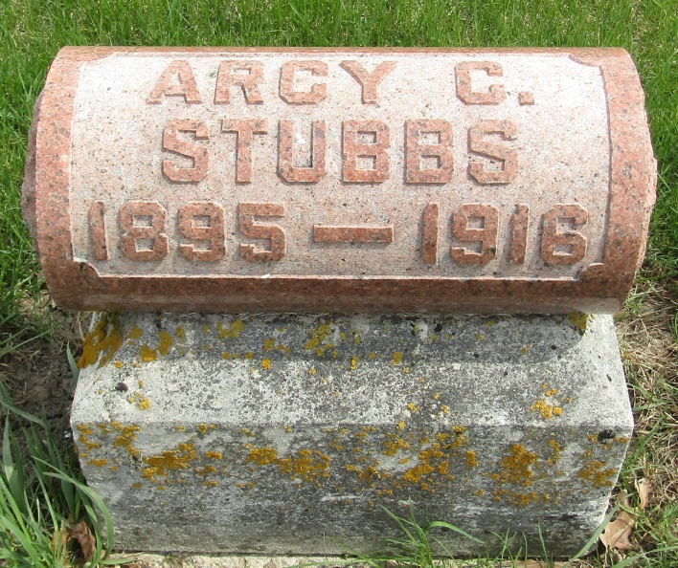

Ivery C Stubbs
in the Indiana, U.S., Death Certificates, 1899-2011
Name: Arcy C Stubbs
Gender: Male
Race: White
Age: 25
Marital status: Single
Birth Date: 13 Apr 1891 [sic]
Birth Place: Wells Co Ind
Death Date: 5 Sep 1916
Death Place: Wayne, Allen, Indiana, USA
Father: Clinton Stubbs
Mother: Bertha Smith
Informant: George Smith; Ossian, Indiana
Burial: September 7, 1916; Ossian, Indiana

