Mary Lula (Summers) Simerman
May 24, 1869 – June 9, 1900

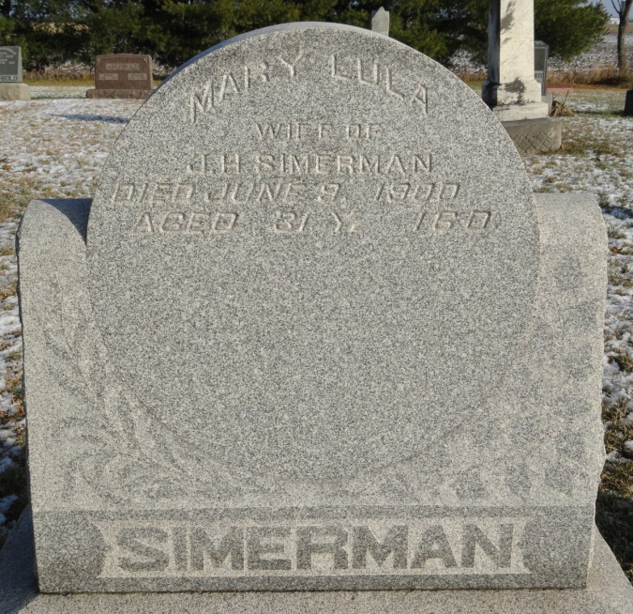

Mary Lula Zimmerman
in the Indiana, U.S., Death Certificates, 1899-2011
Name: Mary Lula Zimmerman
[Mary Lula Simerman]
[Mary Lula Summers]
Gender: Female
Race: White
Age: 30 years, 11 months, 16 days
Marital status: Married
Birth Date: abt 1870
Birth Place: Wells County Ind
Death Date: 9 Jun 1900; childbirth
Death Place: Ossian, Wells, Indiana, USA
Father: Wm Henry Summers
Mother: Margret Pierce
Informant: Margret Summers; Allen County, Indiana
Burial: June 11, 1900; Elhanen Cemetery

