Richard Short
1829 – January 25, 1904

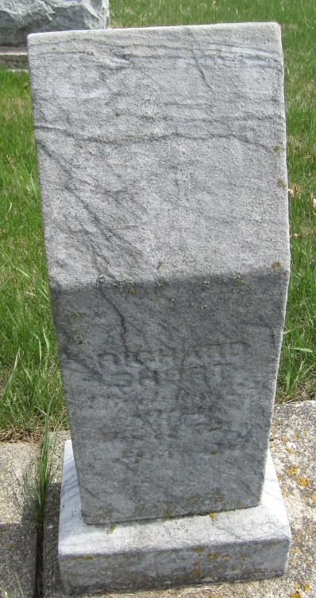

Richard Short from tree Rupright/Gremaux Family Tree
Birth Aug 1829 Ohio, USA
Marriage 16 Sep 1897 Adams, Berkshire, Massachusetts, USA
Residence 1900 Adams, Indiana, USA
Death 25 Jan 1904 Ossian, Wells, Indiana, USA
Father John A. Short (Born 1805)
Mother Elizabeth Teegarden (1811-1892)
Spouse Mahala Shuey (1842-1895)

