Daniel Perry Reynolds
1840 - 1914

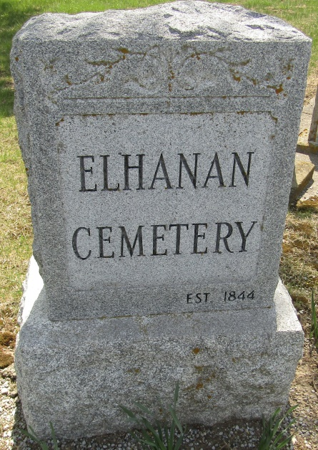

DEATH OF D. P. REYNOLDS

News comes from Strong City, Okla., of the death there one day last week at the home of his daughter, Mrs. John L. Priest, of Mr. D. P. Reynolds, long a respected citizen of Noble, Okla., aged 72 years and 10 months.
He leaves one daughter and her husband and family and the widow and children of his son, W. T. Reynolds, to mourn his loss, besides many warm friends. He was buried by the side of his wife, Mrs. Sarah Reynolds, who preceded him into the Beyond some five years ago at Decatur, Ind.
Mr. Reynolds was a soldier of the civil war, and enjoyed meeting with his comrades and telling war tales. He always swung "Old Glory" to the breeze on every occasion. He was loved and respected by all who knew him for his gentleness and kindness, and will be greatly missed.

Norman Transcript; Norman, Oklahoma
October 21, 1914

