Mary F. Reed
October 10, 1910 – October 17, 1910

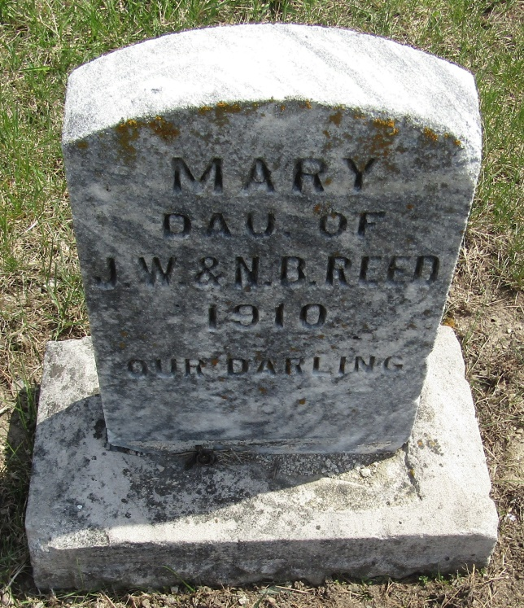

Marry F. Reed
in the Indiana, U.S., Death Certificates, 1899-2011
Name: Marry F. Reed
Gender: Female
Race: White
Age: 7 days
Marital status: Single
Birth Date: 10 Oct 1910
Birth Place: Allen Co., Indiana
Death Date: 17 Oct 1910
Death Place: Pleasant, Allen, Indiana, USA
Father: John Reed
Mother: Nellie B. Conner
Informant: John Reed; Ossian, Indiana
Burial: (can't read date or cemetery) Wells County

