Rachel (Merriman) Paulison
January 4, 1865 – February 18, 1917

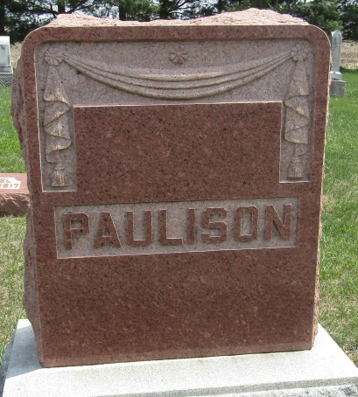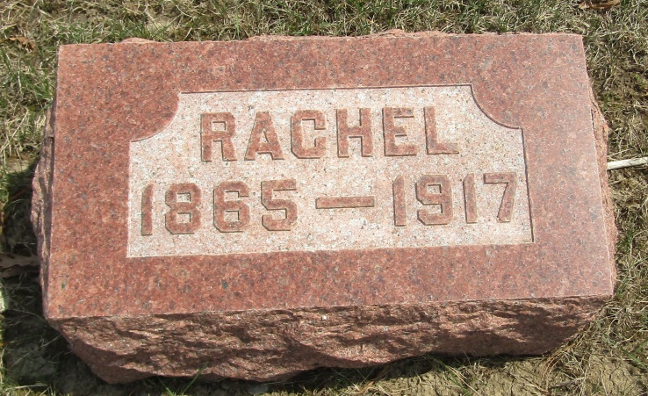

DOUBLE FUNERAL - Will be Held Tuesday for Samuel & Rachel Paulison, Who Died Very - Nearly Together - Husband and Wife, Born on Same Day, Pass Away Only Two Days Apart
Surviving her husband, Samuel M. Paulison, but two days, Mrs. Rachel Paulison, of Fort Wayne, passed away Sunday morning at six o'clock at the St. Joseph Hospital. Her death, like that of Mr. Paulison, which occurred Friday night, was due to pneumonia, and came at the age of fifty-two years. Husband and wife were born on the same day, January 4, 1865.
Mr. and Mrs. Paulison were taken ill almost at the same time and the deaths followed illnesses about a week. Mrs. Paulison was taken to the hospital Friday morning and death came to her husband that evening. The widow's condition had been critical ever since.
Surviving are two sons, aged thirteen an eleven, besides two stepchildren. Mary Steele, wife of James Steele, of west of this city, is a sister. The late Wilson Merriman was a brother.
Mrs. Paulison was a former resident of this city and is a cousin of W. J. Archbold through her mother's relationship to his father, and Mr. Paulison was a cousin of Mr. Archbold through his mother's relationship with Mr. Archbold's father.
The deceased was a member of Loyal Lodge, No. 85, Auxiliary of the B. of R. T., and the Wayne Street M. E. Church.
Double funeral services and burial will take place Tuesday. The services will be held at the home at 1 o'clock and burial will follow at the Elhanan Cemetery, Wells County. Rev. C. C. Travis will officiate.

Decatur Daily Democrat, Adams County, Indiana
February 19, 1917

*****
DOUBLE FUNERAL TUESDAY AT ELHANAN
Mr. and Mrs. S. M. Paulison, who died at Ft. Wayne to be Buried East of Ossian
Mrs. Rachel Paulison, widow of S. M. Paulison, who died Friday passed away yesterday morning at St. Joseph's Hospital. Her death, like that of Mr. Paulison, was due to pneumonia and came at the age of fifty-two years. Husband and wife were born on the same day, Jan. 4, 1865.
Mr. and Mrs. Paulison were taken ill almost at the same time and the deaths followed illnesses of about a week. Mrs. Paulison was taken to the hospital Friday morning and death came to her husband that evening. The widow's condition had been critical ever since.
Surviving are four children, and a sister, Mrs. Mary Steele, of Decatur. The deceased was a member of Loyal lodge No. 85, Auxiliary of the B. of R. T., and of the Wayne Street M. E. Church.
Double funeral services and burial will take place Tuesday. The services will be held at the house at 1 o'clock and burial will follow at the Elhanan Cemetery, Wells County, Rev. C. C. Travis will officiate.

Evening News, Wells County, Indiana
February 19, 1917

*****
MRS. S. M. PAULISON
Following her husband one day after his death, Mrs. S. M. Paulison, formerly a resident of Frankfort, died at her home in Fort Wayne Tuesday. Mr. Paulison succumbed Monday.
Mr. Paulison was an employee of the Clover Leaf when the family resided here. They removed to Fort Wayne about ten years ago.
The funeral of both Mr. and Mrs. Paulison was held in Fort Wayne today.
Frankfort Crescent News, Clinton County, Indiana
Wednesday, February 21, 1917

*****
Indiana, U.S., Death Certificates, 1899-2011
Name: Rachel Paulison
[Rachel Merriman]
Gender: Female
Race: White
Age: 52
Marital status: Widowed
Birth Date: 4 Jan 1865
Birth Place: Ind
Death Date: 18 Feb 1917
Death Place: Ft Wayne, Allen, Indiana, USA
Father: Zachariah Merriman
Mother: Theresa Archbold
Spouse: Samuel M Paulison
Informant: Mrs. Mary Steele; Decatur, Indiana
Burial: February 20, 1917; Elhanan Cemetery

