Infant Myers
January 7, 1904 – January 17, 1904

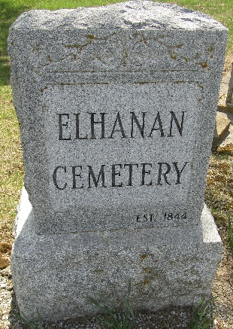
Infant Myers
in the Indiana, U.S., Death Certificates, 1899-2011
Name: Infant Myers
Gender: Female
Race: White
Age: 10 days
Marital status: Not
Birth Date: 7 Jan 1904
Birth Place: Wells Co
Death Date: 17 Jan 1904
Death Place: Ossian, Wells, Indiana, USA
Father: Charley Myers
Mother: Josphine Morton
Informant: Charles Myers; Wells County, Indiana
Burial: Jan ??; Elhanan Cemetery

