Ezekiah Judd
May 26, 1846 – February 12, 1926

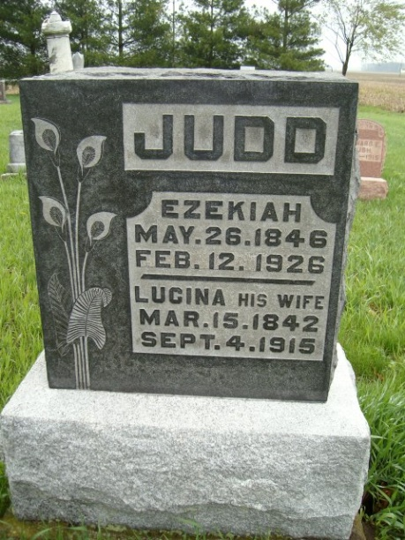

Hezekiah Judd
in the Indiana, U.S., Death Certificates, 1899-2011
Name: Hezekiah Judd
Gender: Male
Race: White
Age: 80
Marital status: Widower
Birth Date: 26 May 1845
Birth Place: Ohio
Death Date: 12 Feb 1926
Death Place: Wayne, Allen, Indiana, USA
Father: John Judd
Mother: Anna Double
Spouse: Lucina White
Informant: Mrs. Charles White; Ossian, Indiana
Burial: February 15, 1926; Elhanan Cemetery

