Susan Harry (Reinhart) Haug
May 26, 1824 – October 8, 1910

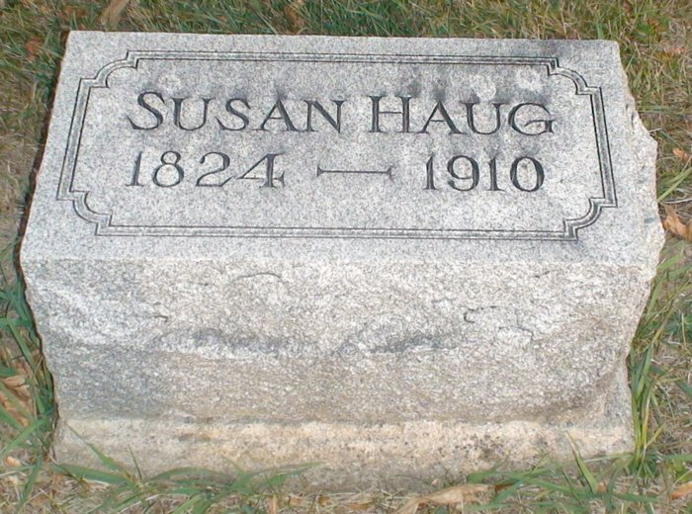

Susan Harry Honk
in the Indiana, U.S., Death Certificates, 1899-2011
Name: Susan Harry Houk
[Susan Harry Reinhart]
Gender: Female
Race: White
Age: 86
Marital status: Widowed
Birth Date: 26 May 1824
Birth Place: Ohio
Death Date: 8 Oct 1910
Death Place: Jefferson, Wells, Indiana, USA
Father: Michel Reinhart
Mother: Mary B. Schearer
Informant: M. H. Wagner; Ossian, Indiana
Burial: October 11, 1910; Elhanan Cemetery

