Charles A. Green
1859 – October 25, 1927

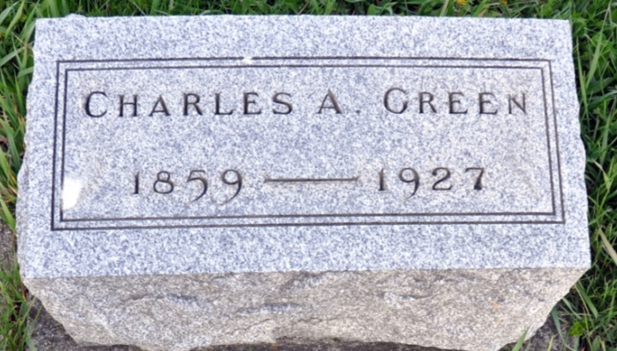

No further information found at this time

