Maynard Everett Dush
November 24, 1883 – November 26, 1915

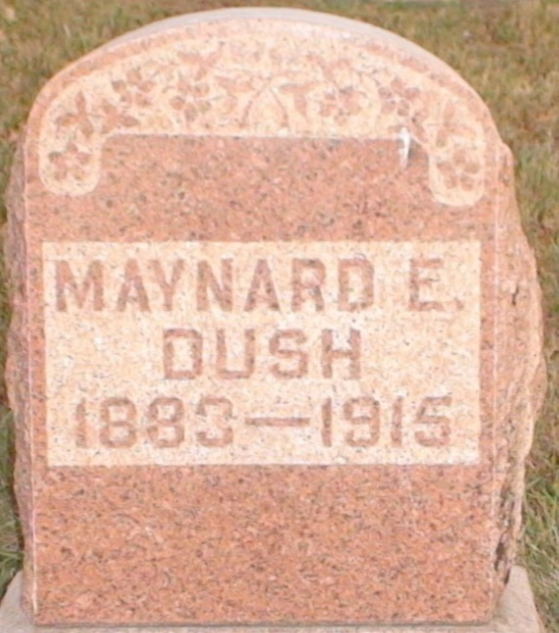

Maynerel W Dush
in the Indiana, U.S., Death Certificates, 1899-2011
Name: Maynerd W Dush
Gender: Male
Race: White
Age: 31 years, 0 months, 2 days
Marital status: Married
Birth Date: 24 Nov (no year stated)
Birth Place: Ind
Death Date: 26 Nov 1915; "some destructive disease"
Death Place: Jefferson, Wells, Indiana, USA
Father: Jerry Dush
Mother: Martha Hoppell
Spouse: Susie
Informant: Mort Waggoner; Ossian, Indiana
Burial: November 28, 1915; Elhanan Cemetery

