Rebecca Double
October 21, 1838 – June 29, 1905

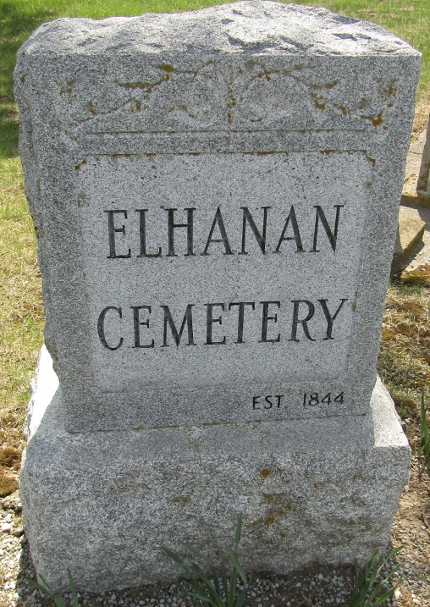

Rebecka Doble
in the Indiana, U.S., Death Certificates, 1899-2011
Name: Rebecka Doble
Gender: Female
Race: White
Age: 66 years, 8 months, 8 days
Marital status: Single
Birth Date: 21 Oct 1828 [sic]
Birth Place: Ohio
Death Date: 29 Jun 1905
Death Place: Ossian, Wells, Indiana, USA
Father: Iach Doble
Mother: Frances Ponte??
Informant: Oliver Doble; Ossian, Indiana
Burial: June 30, 1905; Elhanen Cemetery

