Margaret Mary (Green) Cartwright
April 25, 1863 – June 13, 1922

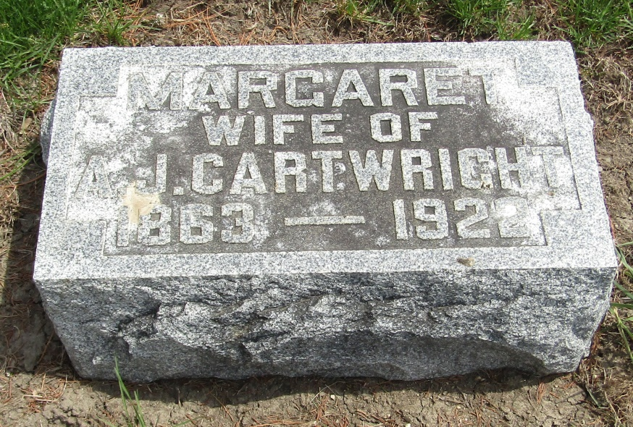

Margaret Mary Cartwright
in the Indiana, U.S., Death Certificates, 1899-2011
Name: Margaret Mary Cartwright
[Margaret Mary Green]
Gender: Female
Race: White
Age: 59
Marital status: Married
Birth Date: 25 Apr 1863
Birth Place: Ohio
Death Date: 13 Jun 1922
Death Place: Marion, Grant, Indiana, USA
Father: Wm Green
Mother: Rebeca
Spouse: Andrew J. Cartwright
Informant: Andrew Cartwright
Burial: June 15, 1922; Wells Cemetery

