Olive Grace Archbold
March 3, 1905 – February 26, 1951

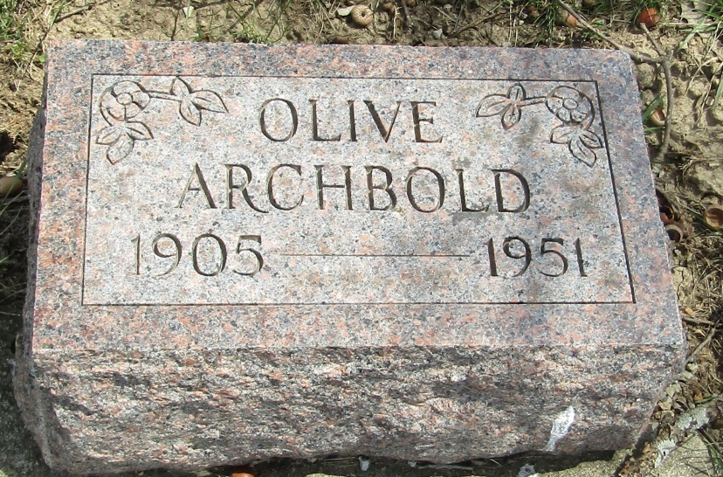

Olive Grace Archbold
in the Indiana, U.S., Death Certificates, 1899-2011
Name: Olive Grace Archbold
Gender: Female
Race: White
Age: 45
Marital status:
Birth Date: 3 Mar 1905
Birth Place: Wells County, Ind
Death Date: 26 Feb 1951
Death Place: Fort Wayne, Allen, Indiana, USA
Father: Frank Archbold
Mother: Eliza Ferguson
Informant: Mrs. Thomas Bridge; sister
Burial: February 28, 1951; Oaklawn Cemetery; Ossian, Indiana

