Fredrick W. Franke
May 7, 1904 – September 26, 1953

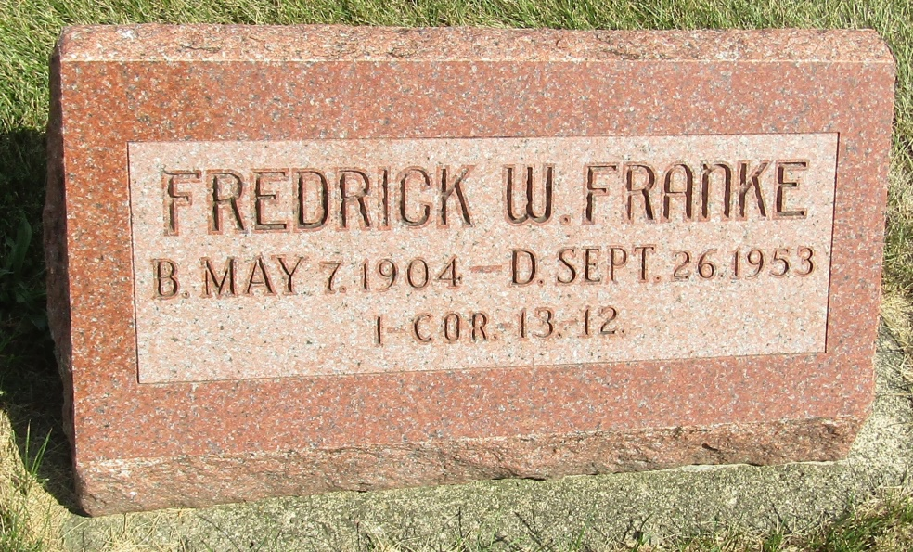

No further information found at this time

