Delin A. Franke
November 13, 1937 – July 9, 2020

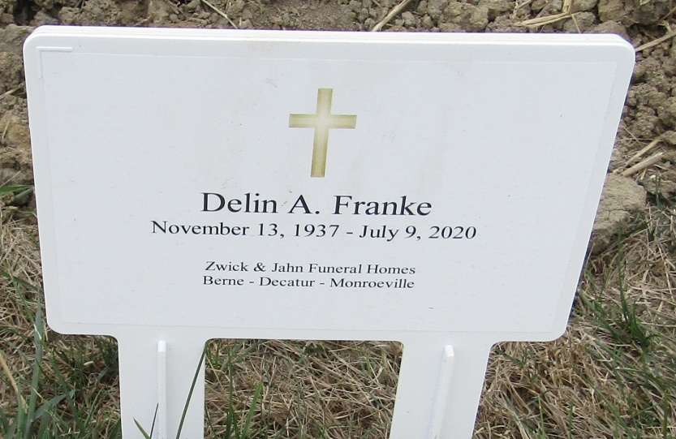

Delin A. Franke, 82, of Ossian, Indiana passed away on July 9, 2020 at Visiting Nurse and Hospice Home, in Fort Wayne, Indiana. His death was unexpected and followed being stricken at his residence on July 4, 2020 of an apparent stroke. He was born on November 13, 1937 in Allen County, Indiana, the son of the late Herbert Franke and the late Martha (Graft) Franke.
Delin was united in marriage to Marilyn Reinking on April 27, 1962 at St. Paul Lutheran Church – Preble and she survives.
Delin served his country in the United States Army Reserves. Delin was a lifelong member of the Bethlehem Lutheran Church, Ossian where he served in various capacities and held many of the major offices in the church. He was also a member of the American Legion Post #241 – Waynedale.
Delin retired from International Harvester following 30 years of service. Following his retirement, he was a maintenance manager for the Northern Wells Community Schools. A lifelong farmer, he also maintained the family farm.
Survivors include his wife, Marilyn Franke of Ossian, Indiana; three daughters, Cheri (Edward) Melching of Carmel, Indiana, Ann (David) Fruchte of Southern Pines, North Carolina, and Kelly (Edward) Walsh of Raleigh, North Carolina; son, Thomas (Michele) Franke of Mason, Ohio; two sisters, Delores Scheumann of Ossian, Indiana and Beverly (William) Braun of Wauwatosa, Wisconsin; and eight grandchildren, Jordan Fruchte, Conner Melching, Megan Fruchte, Christian Melching, Jack Franke, Sophie Walsh, Ava Franke, and Delaney Walsh.
Due to COVID Concerns, private family services and visitation will be held. A public Celebration of Life will be held at a later date when able. Burial will be at Bethlehem Lutheran Church Cemetery.

Zwick & Jahn Funeral Home, Adams County, Indiana
July 10, 2020

