Louise Rosine (Werling) Fackler
November 3, 1857 – September 19, 1914

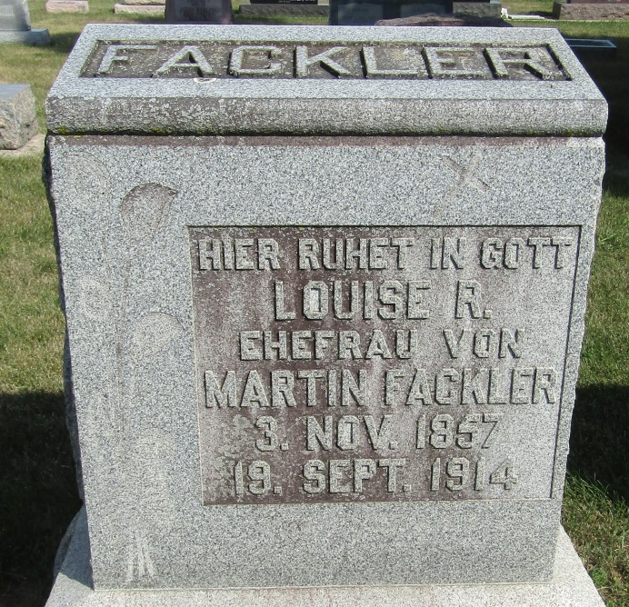

MRS. MARTIN FACKLER DIED AT HOSPITAL
Tocsin Lady Died From Apoplexy, After Four Week's Illness
Louise R. Fackler, aged fifty-six years, the wife of Martin Fackler, residing at Tocsin, died at 6 o'clock Saturday morning at the Lutheran Hospital, Fort Wayne, where she had been a patient for the past four weeks. Her death was due to apoplexy.
She was a daughter of Mr. and Mrs. Andrew Werling and was born in Adams County, her maiden name being Louise Werling.
The husband and three children are living, the children being Mrs. Lydia Stoppenhagen of near Ossian, Hugo and Tillie, at home. Brothers are John, Christ, David and Andrew Werling of Wells county. Sisters are Lena Bauermeister and Sophia Grewe, of Wells County.
The funeral will be Tuesday afternoon at 1 o'clock from Bethlehem Lutheran Church near Tocsin, Rev. A. F. Nease will be in charge. Interment in the Tocsin Cemetery.
Bluffton Evening News, Wells County, Indiana
Sept. 21, 1914

