Mina (Schoppman) Dippel
March 13, 1903 – November 16, 2003

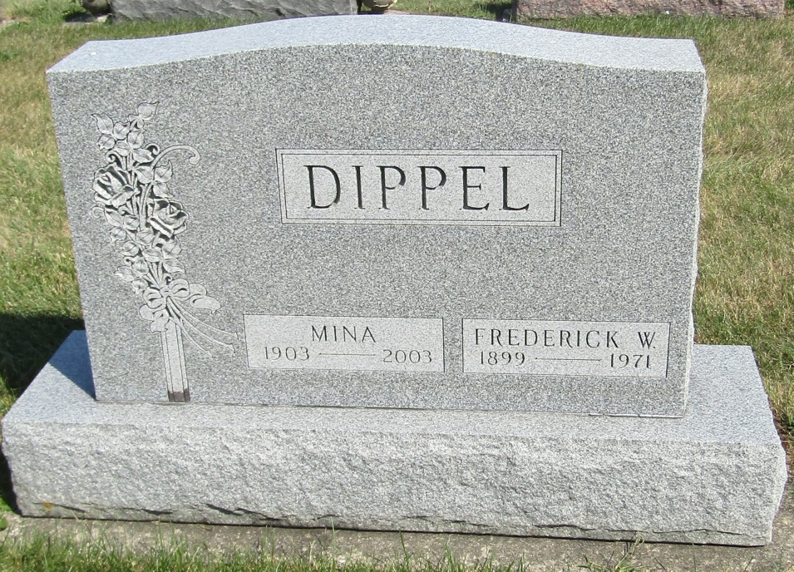

Mina Dippel, 100, formerly of Ossian and Craigville, died Sunday, Nov. 16, 2003, at Lutheran Home, Fort Wayne. Born March 13, 1903, in Hoagland, she was a seamstress with Wolf and Dessauer for 10 years, and the oldest member of Bethlehem Lutheran Church, in rural Ossian.
Surviving are daughter, Wilma L. Bauermeister of Fort Wayne; daughter-in-law, Charlotte Dippel of Ossian; four grandchildren; and eight great-grandchildren. She was preceded in death by her husband, Frederick, son, Rolland, five sisters, and two brothers.
Service is 1:30 p.m. Thursday, with calling one hour prior, at Bethlehem Lutheran Church, rural Ossian, and from 2 to 4 and 6 to 8 p.m. Wednesday at Elzey-Patterson-Rodak Funeral Home, Ossian Chapel. Burial is in the church cemetery.
Memorials to Bethlehem Lutheran Church Building Fund or donor's choice.

Bluffton News-Banner, Wells County, Indiana
November 18, 2003

