Lester Bauermeister
March 16, 1928 – July 22, 2008

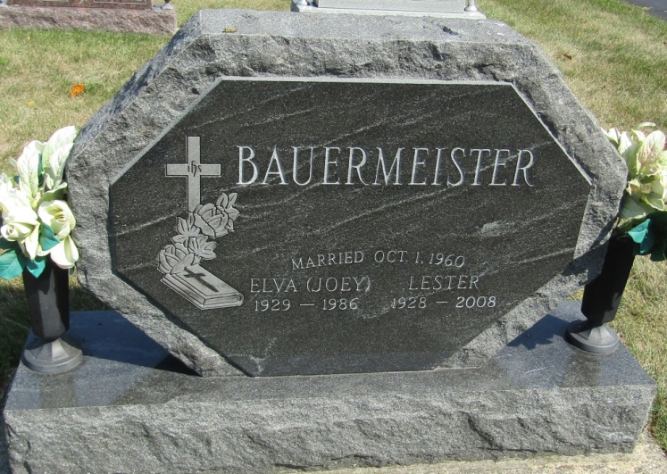

A resident of rural Ossian, Lester Bauermeister, 80, died at his residence Tuesday, July 22, 2008. Born March 16, 1928 in Wells County to Ernest and Edna (Gallmeyer) Bauermeister, he married Elva Joan Joey Reinking Oct. 1, 1960 in Fort Wayne. She preceded him in death Oct. 23, 1986.
A 1947 graduate of Ossian High School, he had served on the Board of Directors of the Old-First National Bank in Bluffton and Ossian. He was a lifelong farmer and a member of Bethlehem Lutheran Church of rural Ossian.
He is survived by a son, Jeff (Lorie) Bauermeister of Ossian; two daughters, Dawn (Steve) Crosby of Fort Wayne and Heidi Bauermeister of Ossian; two sisters, LaVon Scherer of Monroeville and Arline (John) Koomjohn of Oswego, Ill.; and four grandchildren.
Also preceding him in death were brothers Glenn and Norbert Bauermeister.
Services will be at 11 a.m. Saturday at Bethlehem Lutheran with Pastor William R. Brege officiating. Burial will follow in the church cemetery. Calling Friday will be from 2 to 8 p.m. and one hour prior to services Saturday at the church.
Memorials may be made to Bethlehem Lutheran Church.

Bluffton News-Banner, Wells County, Indiana
Wednesday, July 23, 2008

