Ernst C. Bauermeister, Jr.
January 4, 1902 – June 14, 1966

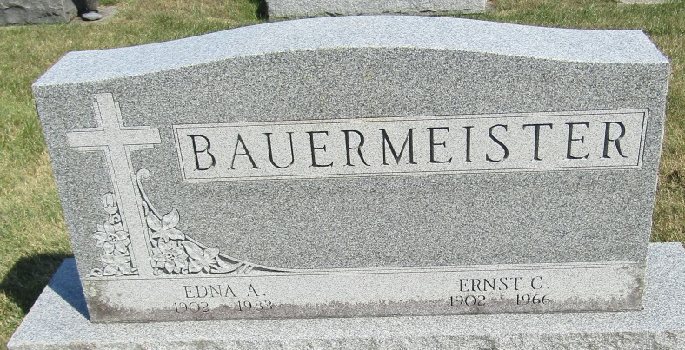

Ernest C Bauermeister
in the Indiana, Death Certificates, 1899-2011
Name: Ernest C Bauermeister
Gender: Male
Race: Caucasian (White)
Age: 64
Marital status: Married
Birth Date: 4 Jan 1902
Birth Place: Indiana
Death Date: 14 Jun 1966
Death Place: Ossian, Wells, Indiana, USA
Father: Henry Bauermeister
Mother: Fredericke Breier
Informant: Edna Bauermeister; wife; Ossian, Indiana
Burial: June 17, 1966; Bethlehem Lutheran Cemetery; Ossian, Indiana

