August Bauermeister
October 26, 1890 – May 23, 1985

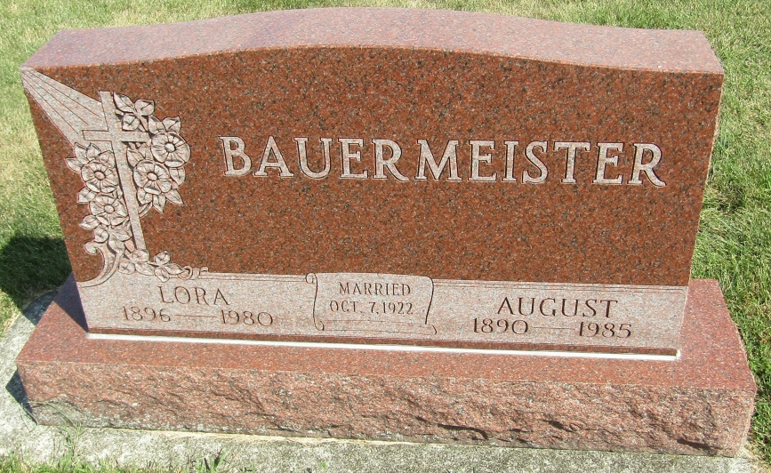

August Bauermeister
in the Indiana, Death Certificates, 1899-2011
Name: August Bauermeister
Gender: Male
Race: White
Age: 94
Marital status: Widowed
Birth Date: 26 Oct 1890
Birth Place: In
Death Date: 23 May 1985
Death Place: Bluffton, Wells, Indiana, USA
Father: Ernst Bauermeister
Mother: Lena Werling
Informant: Ralph Bauermeister; son; Ossian, Indiana
Burial: May 27, 1985; Bethlehem Lutheran Church Cemetery; Ossian, Indiana

