Tony W. Avey
June 27, 1983 – August 15, 1999

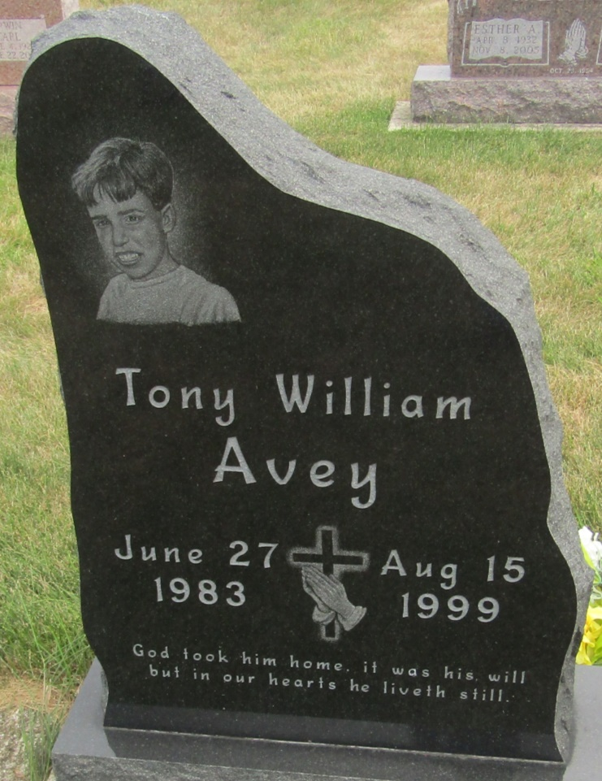

Tony W. Avey
in the Indiana, Death Certificates, 1899-2011
Name: Tony W. Avey
Gender: Male
Race: Caucasian (White)
Age: 16
Marital status: Single
Birth Date: 27 Jun 1983
Birth Place: Bluffon, Indiana
Death Date: 15 Aug 1999; bicycle/auto accident
Death Place: Fort Wayne, Allen, Indiana, USA
Father: Donald Avey
Mother: Donna Oetting
Informant: Donald Avey; father; Ossian, Indiana
Burial: August 19, 1999; Bethlehem Cemetery; Ossian, Indiana

