Delores E. (Grewe) Anderson
June 14, 1933 – February 20, 2009

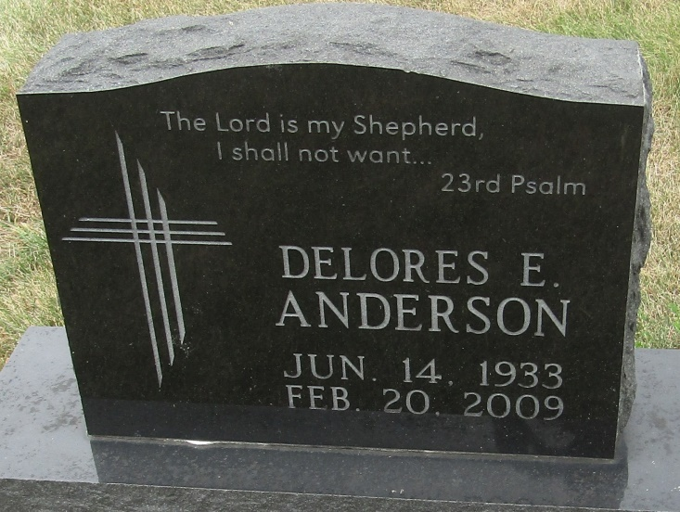

Delores E. Anderson, 75, of Ossian, died Friday, Feb. 20, 2009, at Hospice Home in Fort Wayne. Born June 14, 1933, in Wells County, she retired from the International Division of Central Soya, in 1995. She was a member of the Quarter Century Club at Central Soya, as well as Bethlehem Lutheran Church in Ossian. She enjoyed reading and spending time with her grandchildren.
She is survived by her daughter, Kim (Bruce) Werling of Ossian; and three grandchildren, Nicole Werling of Indianapolis and Allison Kate Werling and Drew Werling, both of Ossian. She was preceded in death by husband, George Robert Anderson, in 1959; parents, Arthur and Sophia (Schaefer) Grewe; brother, Arnold Grewe; and sister, Vera Hoffman.
Service is 11 a.m. Tuesday at Bethlehem Lutheran Church, 7545 N. 650 E., Ossian, with visitation one hour prior to service at the church. Visitation also from 3 to 5 and 6 to 8 p.m. Monday at Elzey-Patterson-Rodak Funeral Home, 120 W. Mill Street, Ossian. Burial in Bethlehem Lutheran Church Cemetery.
Memorials to Bethlehem Lutheran Church Building Fund or donor's choice.

Elzey Funeral Homes, Wells County, Indiana
February 21, 2009

