Clarence E. Stogdill
September 9, 1879 – October 18, 1923

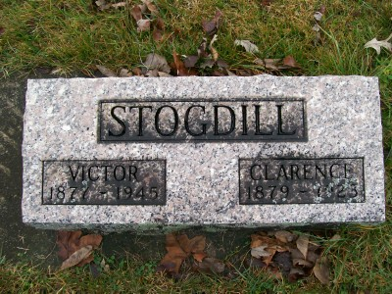
Photo by Scott Shoup

Indiana, Death Certificates, 1899-2011
Name: Clarence E. Stogdill
Gender: Male
Race: White
Age: 44
Marital Status: Single
Birth Date: 9 Sep 1879
Birth Place: Adams Co Ind
Death Date: 18 Oct 1923
Death Place: Harrison, Wells, Indiana, USA
Father: Cristie Stogdill
Mother: Mary Ann Crist
Informant: Carl Hower; Bluffton, Ind.
Burial: Oct. 20, 1923; Bethel Cem.

