Luella (Popejoy) Metz
January 2, 1875 – May 17, 1945

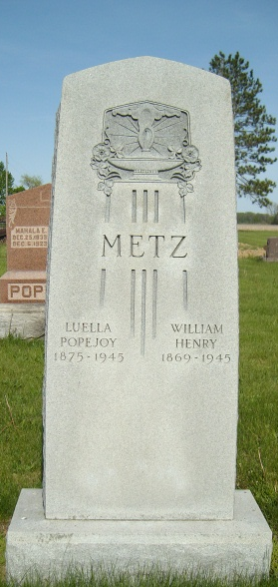
Photo by Smalltown

Mrs. Retta Glancy received word last week of the death of her sister-in-law Mrs. Henry Metz which occurred at Brooklyn, N.Y., where a daughter lives.
Burial was at Warren, Indiana, their home. Mrs. Metz was past 72 years of age. She recently suffered a paralytic stroke and later a heart attack. The Metz family formerly lived here.
The Nelson Gazette; Thursday, May 24, 1945, Page 5

