Richard O. Martin
January 7, 1920 – January 9, 1999

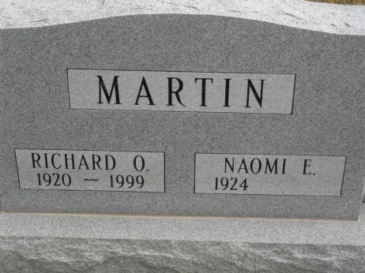

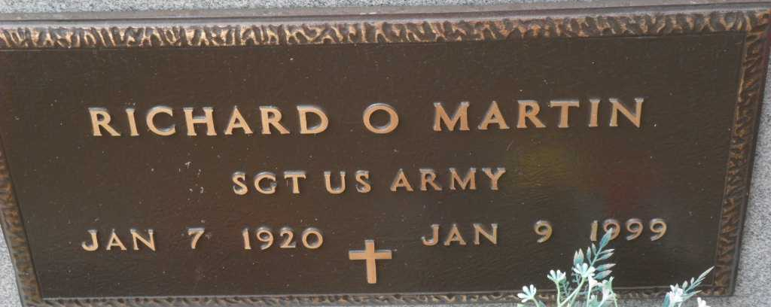
Photo by Pretty Little Grave Seekers

Richard O. Martin, 79, of Bluffton, a member of Disabled American Veterans, died recently at Wells Community Hospital. The Blackford County native worked at Franklin Electric for 17 years. He was a member of American Legion, Poneto United Methodist Church and Disabled American Veterans.
Surviving are his wife, Naomi; sons Kenneth J. of Poneto and Dale A. of Bluffton; a daughter, Karen Eubank of Markle; brothers Claude of Aurora and Harry of Santa Claus; sisters Opal Gaier of Montpelier and Vonda Branson of Winchester; seven grandchildren; three step grandchildren; and six great-grandchildren.
Services are 1:30 p.m. Tuesday at Goodwin Memorial Chapel, Bluffton, with calling two hours before services, and also from 2 to 9 p.m. today. Burial with military services by American Legion Post 111 will be in Grove Cemetery, Poneto. Memorials are to the church.

News-Sentinel, Allen County, IN
January 11, 1999

