Ulysses G. “Bert” Hunnicutt
May 25, 1862 – October 4, 1935

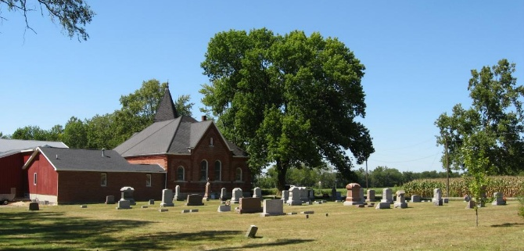
Photo by Tombstoner & Family

Ulysses "Bert" Grant Hunnicutt from tree Stoner/Risser/Clark/Jackson

Birth 25 May 1862 Wells, Indiana, USA
Marriage 29 Apr 1884 Wells, Indiana, USA
Residence 13 Jan 1925 Muncie, Delaware, Indiana, USA
Death 4 Oct 1935 Wells, Indiana, USA
Father Chappell Hunnicutt (1807-1879)
Mother Elizabeth Jane Jennie Roberts (1824-1893)
Spouse Delilah Freel (1865-1925)
6937 People 27 Records 46 Sources
**

Indiana, U.S., Marriage Certificates, 1960-2012

Name Ulyssus or Ulysses Hunnicutt
Gender Male
Marriage License Date 28 Apr 1884
Marriage Date 29 Apr 1884
Marriage Place Wells, Indiana, USA
Spouse Delilah Freel
Officiator John W Rinear

