Freddie Hunnicutt
September 18, 1885 – June 9, 1894

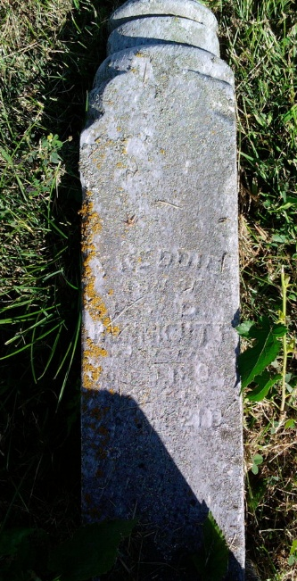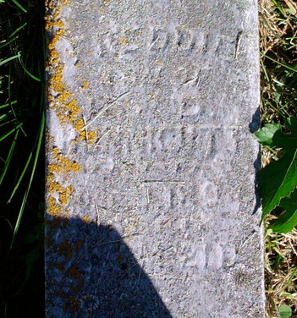
Photo by Thomas Liby

DIED

Freddie Hunnicut died last Saturday at the home of Mrs. Margaret Burris in Liberty township at the age of fourteen years. The funeral occurred Sunday at Bethel cemetery.

Bluffton Banner, Wells County, Indiana
Wed., June 13, 1894
**

Freddie Hunnicutt from tree Hiday Family Tree

Birth 1885 Wells, Indiana, USA
Death 9 Jun 1894 Wells, Indiana, USA
Father Ulysses G Bert Hunnicutt (1862-1935)
Mother Delilah Freel (1865-1925)
535 People 0 Records 2 Sources

