Scott C. Hughes
February 8, 1853 – February 25, 1878

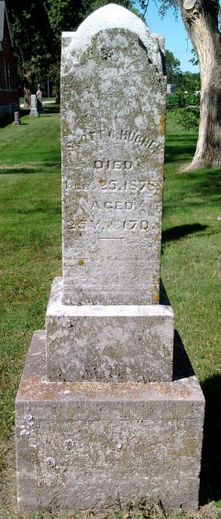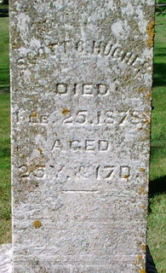
Photo by Thomas Liby

Scott C Hughes from tree Tranor Family Tree

Birth 8 Feb 1853 Wells, Indiana, USA
Residence 1870 Wells, Indiana, USA
Death 25 Feb 1878 Wells, Indiana, USA
Father Robert Scott Hughes (1824-1894)
Mother Sarah Martha Lanning (1822-1910)
150314 People 1 Record 8 Sources

