Robert S. Hughes
April 12, 1824 – August 24, 1894

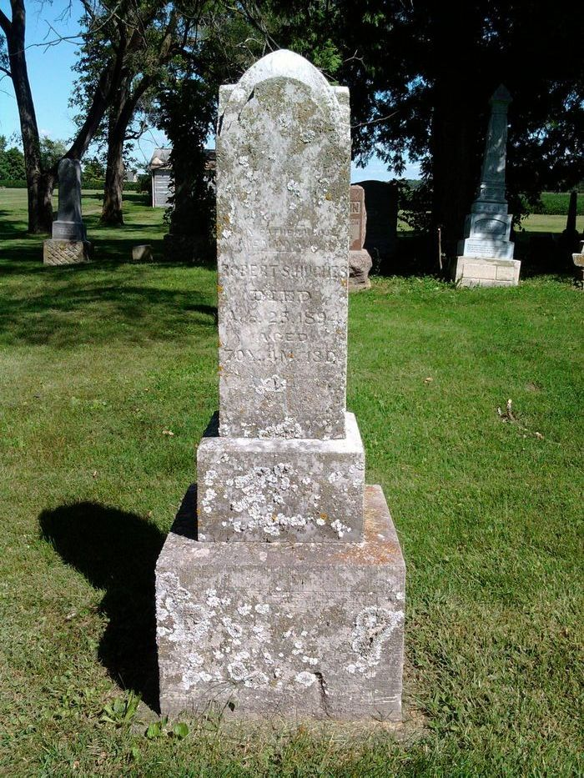
Photo by Thomas Liby

Robert S. Hughes was born in Guernsey County, Ohio, April 12th, 1824; was married to Sarah M. Lanning Feb. 1st, 1844 and died Aug. 24th, 1894; he leaves an aged wife and one daughter, Mrs. John Ulmer, to mourn his loss, the rest of his children having preceded him to that better land.
He removed to Wells county, Indiana in the spring of 1848, where he lived until his death. He had reached the ripe old age of 70 years, 4 months and 12 days; he was converted and joined the church at the age of twenty years and has lived a faithful Christian life all the years since and he died on the triumph of living faith. During his sickness he was never heard to murmur or complain one word; he seemed to long for the hour of departure that he might enjoy that sweet rest remains for the faithful.
He was loved and respected by all who knew him; his funeral occurred on Sunday at Bethel church conducted by Rev. Foster of Poneto charge. Brother Edward Bartlemay of Bluffton and friends sang some beautiful hymns, some that the dear brother loved to sing while living and able to lift his voice in praise. His funeral was one of the largest attendance ever held in this vicinity being followed by one hundred and sixty-four carriages. A kind husband, a loving father, a true and faithful neighbor has passed away; we will not weep but will only say: (prayer)

Bluffton Banner, Wells County, Indiana
Wed., Aug. 29, 1894
**

Robert Hughes from tree Harris/ Walker Family Tree

Birth 12 Apr 1824 Ohio, USA
Marriage 1 Feb 1844 Guernsey, Ohio, USA
Residence 1870 Vera Cruz, Wells, Indiana, USA
Death 24 Aug 1894 Bluffton, Wells, Indiana, USA
Father Joseph Hughes (1782-1858)
Mother Rebecca Stone (1790-1842)
Spouse Sarah M Lanning (1822-1910)

