Simon Huffman
1826 – January 20, 1871

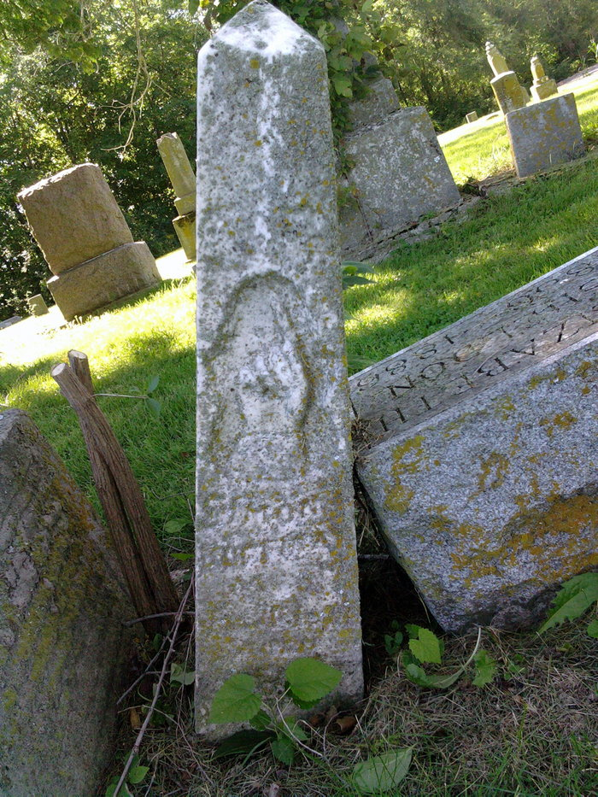
Photo by Thomas Liby

No further information found at this time.

