Roy E. Hower
May 13, 1895 – December 17, 1918

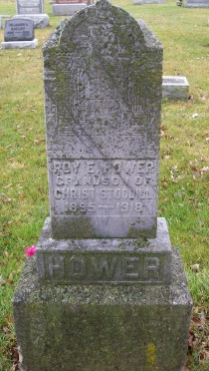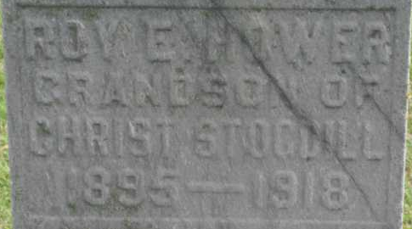
Photo by Pretty Little Grave Seekers

Roy E Hower
in the Indiana, U.S., Death Certificates, 1899-2017

Name Roy E Hower
Gender Male
Race White
Marital Status Single
Age 23
Birth Date 13 May 1895
Birth Place Bluffton, Indiana
Death Date 17 Dec 1918
Death Place Rockville, Parke, Indiana, USA
Father J W Hower
Mother Elalie Stogdill
Informant Hospital records; Rockville, Indiana
Burial December 20, 1918; Bluffton, Indiana

