Polly (Myers) Houdyshell
October 15, 1826 – February 2, 1901

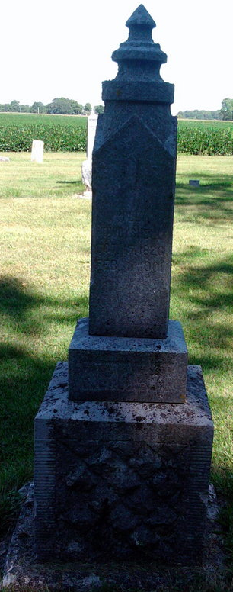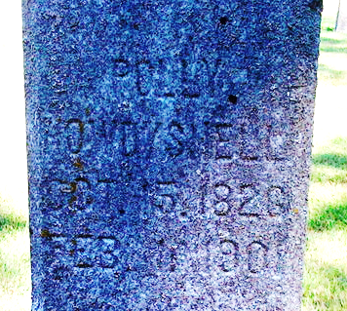
Photo by Thomas Liby

Polley Houdyshell
in the Indiana, U.S., Death Certificates, 1899-2017

Name Polley Houdyshell
[Polley Myers]
Gender Female
Race White
Marital Status Widow
Age 74 years, 3 months, 16 days
Birth Date abt 1827 [17 Oct 1826]
Birth Place Hocking Co Ohio
Death Date 2 Feb 1901
Death Place Bluffton, Wells, Indiana, USA
Father Sameel Myers
Mother Unknown
Informant George Gavat??; Bluffton, Indiana
Burial February 3, 1901; Bethel Cemetery

