Nanny M. (Shelden) Horner
February 15, 1882 – February 14, 1908

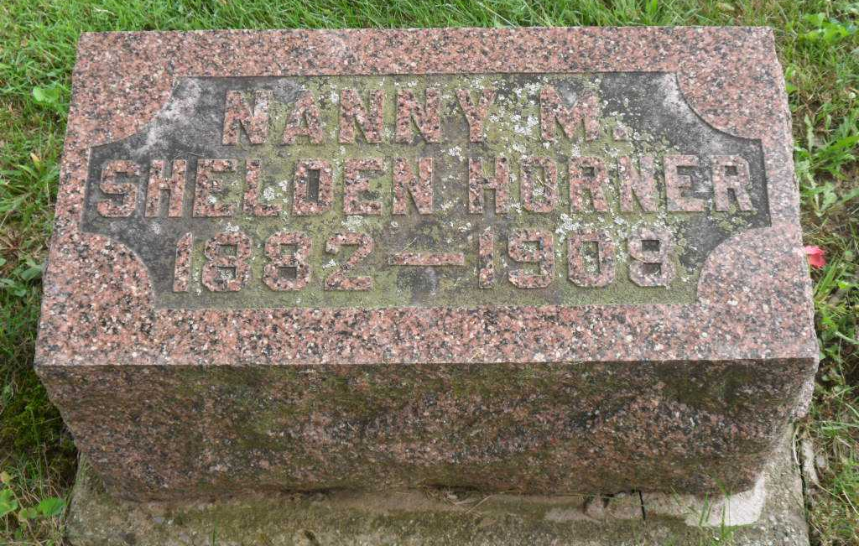
Photo by Pretty Little Grave Seekers

Nannie May Horner
in the Indiana, U.S., Death Certificates, 1899-2017

Name Nannie May Horner
[Nannie May Sheldon]
Gender Female
Race White
Marital Status Married
Age 25
Birth Date 15 Feb 1882
Birth Place Wells County
Death Date 14 Feb 1908
Death Place Bluffton, Wells, Indiana, USA
Death Registration Date 1908
Father Joseph Sheldon
Mother Mary Ann Sawyer
Informant Ed Pierce; Bluffton, Indiana
Burial February 16, 1908; Bethel Cemetery

