W. A. Hopkins
March 5, 1841 – January 6, 1860

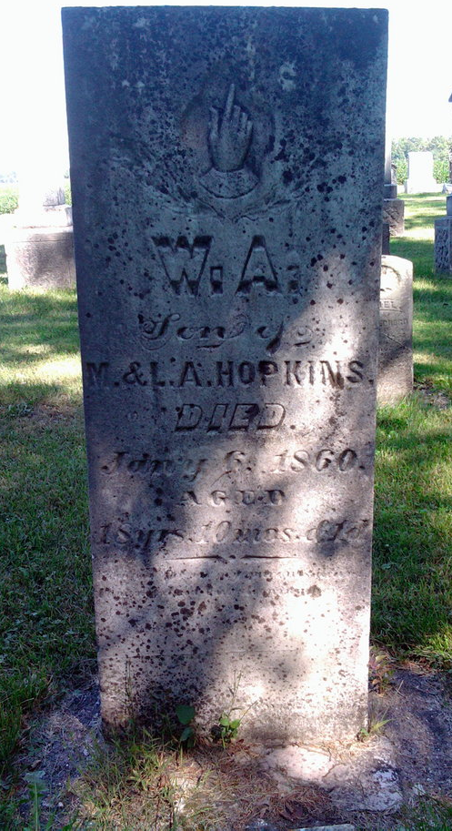
Photo by Thomas Liby

No further information found at this time.

