Sarah Hopkins
September 28, 1820 – June 30, 1839

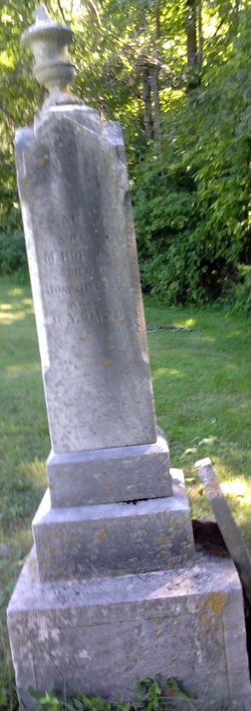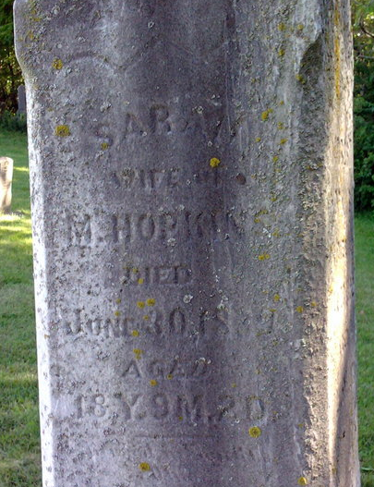
Photo by Thomas Liby

No further information found at this time.

