Moses Hopkins
September 7, 1819 – January 20, 1892

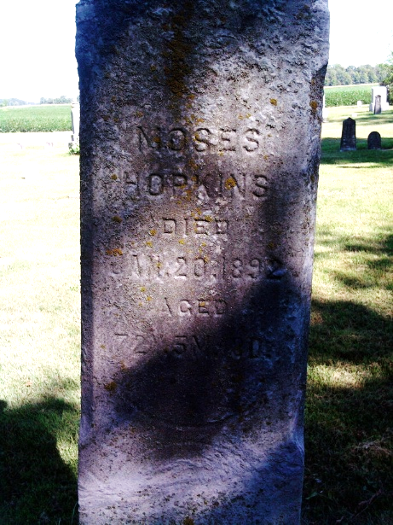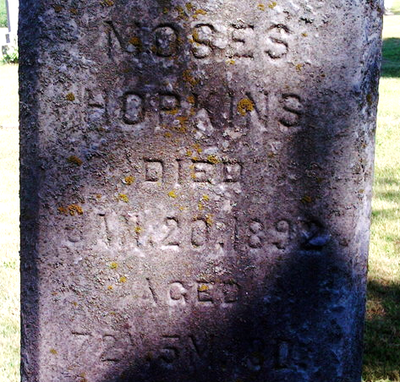
Photo by Thomas Libby

Ohio, U.S., County Marriage Records, 1774-1993

Name Moses Hopkins
Gender Male
Marriage Date 15 Feb 1840
Marriage Place Fayette, Ohio, USA
Spouse Lueretin Jones
Film Number 000292630
**

Indiana, U.S., Marriages, 1810-2001

Name Moses Hopkins
Gender Male
Race White
Event Type Marriage Registration (Marriage)
Birth Place Ross, Ohio
Marriage Date 9 Oct 1890
Marriage Place Poneto, Indiana, United States
Residence Place Wells
Father Moses Hopkins
Mother Mercy Kerkendall
Spouse Mary L Phipps
Page 34
**

Moses B. Hopkins from tree Huggins Family Tree

Birth 7 Sep 1819 Ohio, USA
Residence 1880 Wells, Indiana, USA
Marriage 9 Oct 1890 Poneto, Wells, Indiana, USA
Death 20 Jan 1892 Bluffton, Wells, Indiana, USA
Father Moses Hopkins (1780-1839)
Mother Massey Kuykendall (1784-1828)
Spouse Lucretia Jones (1815-1886)
1134 People 6 Records 21 Sources

