Lucretia A. (Jones) Hopkins
December 23, 1815 – February 8, 1886

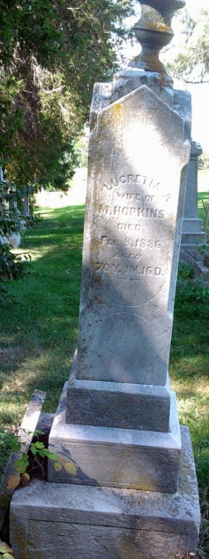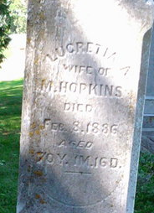
Photo by Thomas Liby

Lucretia A Jones from tree Lori Hilsmier Ramotar Family Tree

Birth 22 Dec 1815 Virginia, USA
Residence 1880 Wells, Indiana, USA
Marriage 9 Oct 1890 Poneto, Wells, Indiana, USA
Death 8 Feb 1886 Wells, Indiana, USA
Spouse Moses Hopkins (1819-1892)
624 People 11 Records 28 Sources
**

Ohio, U.S., County Marriage Records, 1774-1993

Name Lueretin Jones
Gender Female
Marriage Date 15 Feb 1840
Marriage Place Fayette, Ohio, USA
Spouse Moses Hopkins
Film Number 000292630

